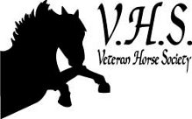
The 2024 National
Veteran Championships

Competitor’s Name:

Horse’s / Pony’s Name:

Owner’s Name:

Nights Stabling Booked:

Vehicle Reg. & Colour:

Emergency Number (s):

