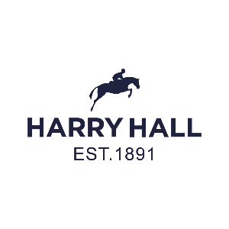



Press Release: For immediate release

**Major championship sponsorship announcement between Harry Hall and the Veteran Horse Society.**

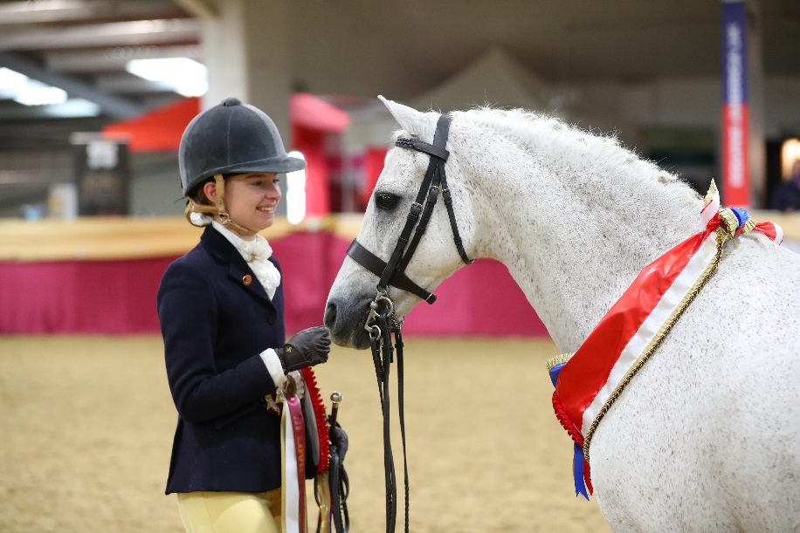**Harry Hall International Limited is delighted to announce a significant sponsorship agreement for the Veteran Horse Society National Championships later this year.**

**The Veteran Horse Society National Championships is the largest veteran equine event in the UK. It’s held over three days at Arena UK in Lincolnshire, the UK's largest equine showground and includes the prestigious end of season Supreme Finals and the much-acclaimed Veteran of the Year. The event offers over 120 classes (showing, dressage, jumping and fun classes), most of which are open to members as well as non-members, with no qualification necessary.**

Miss Millie Bowles & Cottrell Riverdance

**The Veteran Horse Society is solely dedicated to the care and welfare of horses and ponies over the age of 15. The championships celebrate these horses and their owners and the care they bestow on them. The Society’s principles are closely aligned with those of Harry Hall and the Harry Hall One Club, offering affordable membership, insurance and shopping for horse owners, allowing them to look after their equines affordably.**

**Liz Hopper, CEO of Harry Hall explains**, "We're horse owners and riders too and we understand that this is a lifestyle, not a hobby. That's why, in 2017, we created the One Club where our members benefit from our mission to make horse ownership more affordable. We've been helping horse owners for over 130 years and we’re delighted to be supporting the Veteran Horse Society National Championships”.

Julianne Aston, Founder of the Veteran Horse Society, said: "We are delighted to be working alongside Harry Hall and we are sure this will be a long and successful partnership, not only for the Championships but for the Society, our supporters and most importantly, their veterans.

Allen & Page, an innovative, family-owned company sponsors the Veteran Horse Society showing series and championships, formulating and manufacturing non-GM horse feeds. "We are thrilled to be working with Harry Hall over the three days of the Championships," said Tim Page, Sales Director of Allen & Page.

**The British company Harry Hall has been synonymous with equestrians since 1891. Their passion to deliver the best brands and products continues as much today as it did over a century ago. With a mission to make riding and horse ownership more affordable, the Harry Hall One Club was launched in 2017, offering exclusive product discounts, year-round savings, free delivery, and much more.**

To find out more about the Harry Hall One Club, please visit www.harryhall.com. For more information on the Veteran Horse Society and the National Championship, please visit https://www.veteran-horse-society.co.uk/

Media Contact; Rachel.Bowles@harryhall.com Tel: 07782326269

***Boiler plate:*** *Founded in 1891 Harry Hall has been serving equestrians for over 125 years, offering membership, insurance and products. The Harry Hall One Club is an online community of like-minded equestrians who enjoy discounts off insurance and products all year round at harryhall.com. In addition, member benefits include discounts off other equestrian brands, a bi-annual member magazine and monthly competitions. Harry Hall is a one stop shop for all your equestrian needs.*